3. Git-HOL Handson
Step 1: Create a New Branch
Command Used:
git branch GitNewBranch
Description:
A new branch named GitNewBranch was created.

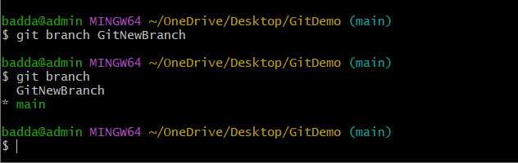
Step 2: Switch to the Branch and Commit Changes
Commands Used:
git checkout GitNewBranch
git add branch.txt
git commit -m "Added branch file"
Description:
Switched to the new branch, added a file, and committed the changes.
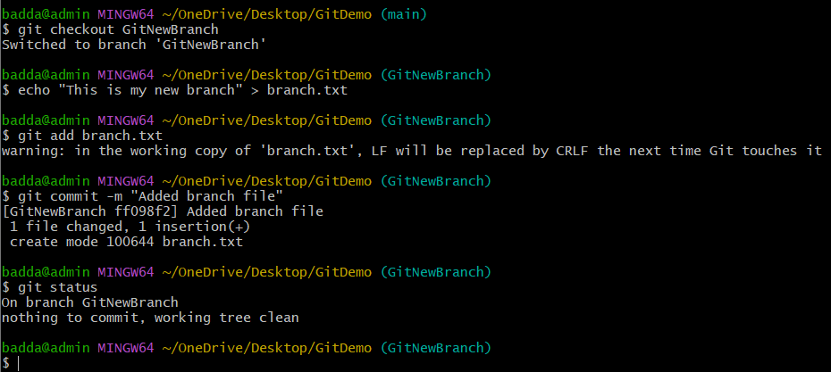

Step 3: Merge the Branch
Commands Used:
git checkout main
git merge GitNewBranch
Description:
Merged the GitNewBranch into the main branch.
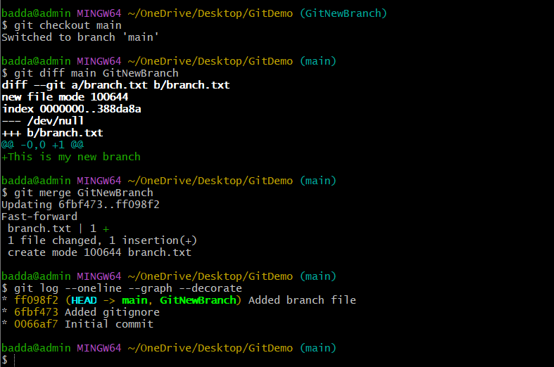
Step 4: Delete the Branch and Verify Status
Commands Used:
git branch -d GitNewBranch
git status
Description:
Deleted the merged branch and verified that the working tree is clean.
